**Laboratory 1:**

Uncertainty and Statistics

**Name:** Omar Ozgur

**Date Performed:** January 14, 2016 (01/14/16)

**Lab:** Section 7, Thursday 8am

**TA:** Nicholas Rombes

**Lab Partner:** Uday Alla

**1.1 Introduction**

The purpose of this laboratory experiment was to familiarize us with modern data acquisition techniques and error analysis methods. In the first section of the lab, a noise voltage was generated by a circuit, which was recorded on a computer through the use of a myDAQ data acquisition device. Software was used to gather voltage data for various sample sizes, and the mean values for multiple ensembles were analyzed in order to view the effects of sample size on uncertainty. In the second portion of the lab, the effects of error propagation due to addition was shown by analyzing the mean and standard deviation of data from two separate noise voltages, as well as from the addition of the voltages. In the third lab portion, the given error propagation equation was used to analyze the propagation of error due to products and ratios. The analysis of this data allowed for experimental verification of error propagation formulas.

**2.1 Experimental Results**

2.1.1 Varying Ensemble Size

In the first part of the laboratory experiment, a pre-configured circuit board was attached to a direct current (DC) power supply with wires. A wire was used to pass a noise voltage from the circuit board to an analog-digital converter (ADC), and a myDAQ device was used to record data on a computer. The setup is shown in Figure 1.

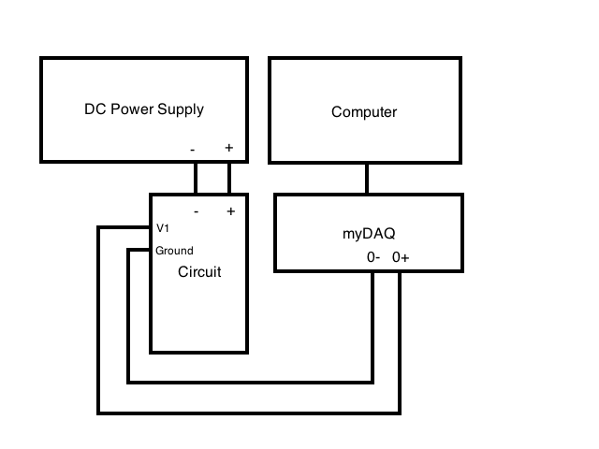

Figure 1: Experiment part 1 setup: In the first part of the experiment, a DC power supply provided 30V to the circuit board. The V1 and ground outputs on the circuit were connected to the ADC in channel 0 of the myDAQ system. The myDAQ system relayed information to the computer so that it could be recorded.

By using the provided 4BL software, voltage readings were recorded for 6 different sample sizes N. 10 ensembles were recorded for each sample size, and the mean and standard deviation values were recorded for each ensemble. The standard deviations of the mean ${σ_{\overline{V}}}_{N}$ were calculated by finding the standard deviation of the 10 mean values for each ensemble. These values were calculated by using equation 1. The same values were recalculated based on equation 2, which relies on statistical theory. Each calculated standard deviation was used to quantify random uncertainty for the respective ensembles, and the data was plotted on a graph in Figure 3.

${σ_{\overline{V}}}_{N}= \sqrt{\frac{1}{N}\sum_{i=1}^{N}{{\left(x_{i}-\overline{x}\right)}^{2}}}$ (1)

${σ_{\overline{V}}}_{N}= \sqrt{\frac{1}{N}}σ_{N_{i}}$ (2)

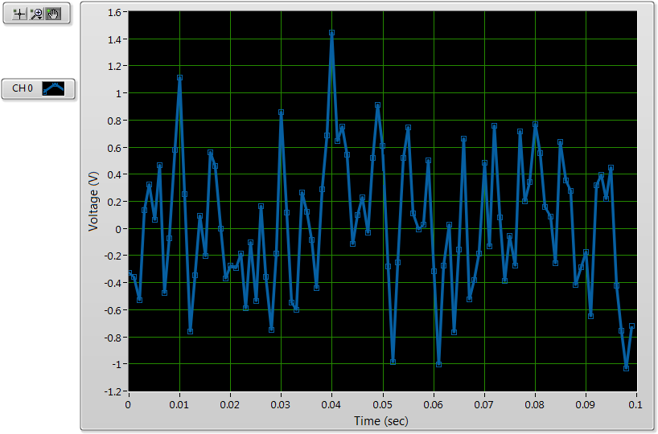

Figure 2: Voltage readings from one ensemble: This figure displays data that was recorded for one ensemble of sample size 100. The seemingly random fluctuations are due to the generated noise voltage from the circuit. For large sample sizes, the graphs visually showed that the voltage readings centered at approximately 0 V.

Figure 3: Uncertainty based on ensemble size: This graph displays the quantified random uncertainty values that were calculated for the ensembles of each sample size. The values marked as “measured” were based on the standard deviations of voltage readings for every ensemble, which were calculated with Equation 1. The values marked as “theoretical” were found based on Equation 2. The similarity between the measured and theoretical values gives visual verification of the results of the equations.

2.1.2 Addition of Random Voltages

In the second portion of the lab, the random voltages $V_{1}$ and $V_{2}$ were connected to the myDAQ system, and the voltage readings were recorded for one ensemble of size N = 10,000. After connecting the two voltages to the corresponding inputs of the adding circuit, the output voltage was connected to the myDAQ system as shown in Figure 4, and the voltage readings were recorded once again for one ensemble of size N = 10,000. The mean and standard deviation values for each voltage are shown in Table 1.

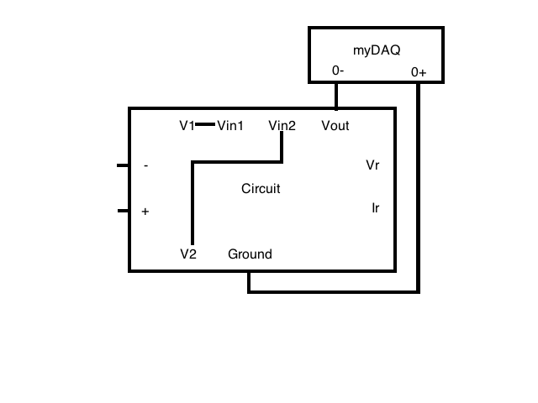

Figure 4: Experiment part 2 setup: In order to record the voltage based on the addition of the two random voltages, $V_{1}$ and $V_{2}$ were connected to $V_{in_{1}}$ and $V_{in_{2}}$ respectively. The output voltage from $V_{out}$ was connected to the myDAQ system so that the data could be recorded on a computer.

|  |  |  |  |
| --- | --- | --- | --- |
|  | $V_{1}$ (V) | $V_{2}$ (V) | $V_{out}$ (V) |
| Mean | 0.007 | -0.0063 | -0.0246 |
| Standard Deviation | 0.4777 | 0.5639 | 0.6968 |

Figure 5: Mean and standard deviations for part 2: This table displays the recorded mean and standard deviations for the two noise voltages $V_{1}$ and $V_{2}$, as well as for the addition of the two voltages $V_{out}$. One ensemble with size N = 10,000 was taken for each voltage.

**3.1 Analysis**

3.1.1 Varying Ensemble Size

Based on the 10 mean voltage and standard deviation measurements that were taken for 6 different sample sizes, the standard deviation of the mean values ${σ_{\overline{V}}}_{N}$ was calculated in two different ways. The first way involved the traditional method of taking the standard deviation of the 10 measured mean values by using equation 1. The second way involved statistical theory, and was done by inputting the sample size N and the measured standard deviation of a single ensemble ${σ_{N}}_{i}$ into equation 2.

Based on the results shown in Figure 3, the close proximity of points calculated by both methods visually indicates that the statistical theory method of calculating the standard deviation of mean values is valid. The linear downward trend of the data shows that as the sample sizes increased, the standard deviation of mean values decreased. Since the standard deviation of mean values was used to quantify random uncertainty, the experiment showed that larger sample sizes tended to decrease uncertainty in data values. The data agrees well with equations 1 and 2, which both show that larger ensemble sizes would lead to smaller calculated standard deviations.

Only one value for an ensemble size of N = 1000 based on equation 1 deviated slightly from this trend. Since the measured mean voltage values for any particular ensemble were based on random voltages, it is possible that the mean had a particularly large deviation from 0 V for a few ensembles. This irregularity could have possibly been removed if more than 10 ensembles had been taken for each sample size.

3.1.2 Addition of Measured Quantities

By inputting the standard deviation values ${σ_{\overline{V}}}_{1}$, ${σ_{\overline{V}}}_{2}$, and ${σ_{\overline{V}}}_{out}$ into equation 2, along with the sample size of N = 10,000, the measured values ${\overline{V}}_{1}$, ${\overline{V}}_{2}$, ${\overline{V}}_{out}$, as well as their uncertainties, were calculated to be the following:

$${σ_{\overline{V}}}_{1}=0.0048 V$$

$${\overline{V}}_{1}=(0.0070±0.0048)V$$

$${σ_{\overline{V}}}_{2}=0.0056 V$$

$${\overline{V}}_{2}=(-0.0063±0.0056)V$$

$${σ_{\overline{V}}}_{out}=0.0070 V$$

$${\overline{V}}_{out}=(-0.0246±0.0070)V$$

Rather than taking measured values of ${\overline{V}}_{out}$ based on the physical addition of voltages ${\overline{V}}_{1}$ and ${\overline{V}}_{2}$ in the circuit, the sum ${\overline{V}}_{sum}$ of the mean voltages of the two input voltage sources could be calculated based on the following equations:

${\overline{V}}_{sum}=-({\overline{V}}_{1}+{\overline{V}}_{2})$ (3)

$σ_{\overline{F}}=\sqrt{{\left(\frac{∂f}{∂x}\right)}^{2}{\left(σ_{\overline{x}}\right)}^{2}+{\left(\frac{∂f}{∂y}\right)}^{2}{\left(σ_{\overline{y}}\right)}^{2}}$ (4)

Based on equation 4, the uncertainty ${σ_{\overline{V}}}_{out}$ can be calculated by the following equation:

$σ_{{\overline{V}}_{sum}}=\sqrt{σ_{{\overline{V}}_{1}}^{2}+σ_{{\overline{V}}_{2}}^{2}}$ (5)

By using equation 5, ${\overline{V}}_{sum}$ and ${σ_{\overline{V}}}_{out}$ can be calculated as follows:

$$σ_{{\overline{V}}_{sum}}=0.0074 V$$

$${\overline{V}}_{sum}=\left(-0.0007±0.0074\right)V$$

By comparing the measured value ${\overline{V}}_{out}$ with the calculated value ${\overline{V}}_{sum}$, it can be seen that the values do not agree with each other based on the uncertainty ranges. Since only one ensemble was recorded for each voltage, the random voltage fluctuations likely caused the mean values to vary in each trial, which caused the discrepancy between the two values.

Although the calculated mean values do not agree with each other, their calculated uncertainty values $σ_{{\overline{V}}_{out}}$ and $σ_{{\overline{V}}_{sum}}$ are the same value when taken to one significant value. This makes sense due to the fact that addition of the two voltages, both in theory and in practice, increases the measurements of uncertainty similarly.

3.1.3 Quotient of Measured Quantities

As shown in the lab manual, a general formula for the uncertainty for products and ratios can be found by using the general error propagation equation from equation 4 with a simple example, such as the formula I = V/R based on Ohm’s law. The steps for this example are shown below.

$\frac{∂I}{∂V}=\frac{1}{R}$

$\frac{∂I}{∂R}=\frac{-V}{R^{2}}$

$$σ_{\overline{I}}^{2}=\sqrt{{\left(\frac{1}{R}\right)}^{2}{\left(σ_{\overline{V}}\right)}^{2}+{\left(\frac{-V}{R^{2}}\right)}^{2}{\left(σ_{\overline{R}}\right)}^{2}}$$

$$σ_{\overline{I}}^{2}=\frac{1}{R^{2}}\left({σ_{\overline{V}}}^{2}+\frac{V^{2}}{R^{2}}{\left(σ_{\overline{R}}\right)}^{2}\right)=\frac{I^{2}}{V^{2}}\left({σ_{\overline{V}}}^{2}+\frac{V^{2}}{R^{2}}{\left(σ_{\overline{R}}\right)}^{2}\right)$$

$\frac{σ_{\overline{I}}^{2}}{I^{2}}=\frac{{σ_{\overline{V}}}^{2}}{V^{2}}+\frac{σ_{\overline{R}}^{2}}{R^{2}}$ (6)

Equation 6 can be rewritten in order to accommodate the function F = xy.

$σ_{F}^{2}={\overline{F}}^{2}\sqrt{{\left(\frac{σ_{x}}{\overline{x}}\right)}^{2}+{\left(\frac{σ_{y}}{\overline{y}}\right)}^{2}}$ (7)

Based on the given values $σ_{x}=0.1$, $σ_{y}=0.001$, and $\overline{x}=\overline{y}=1$, the uncertainty $σ_{F}$ can be calculated by using equation 7.

$\overline{F}=1$.0

$$σ_{F}=0.1$$

If the uncertainty $σ_{F}$ is recalculated without the term $σ_{y}$, the change in values is of about 5 orders of magnitude, which is small enough to ignore in most cases. This shows that since the value of $σ_{x}$ is much higher than that of $σ_{y}$, x is the major source of error.

**4.1 Conclusion**

The objective of this experiment was to help familiarize us with error analysis and data acquisition. In the first portion of the lab, the analysis of voltage data shown in Figure 3 showed the uncertainty in measurements tend to decrease when the sample size is increased. The similarities between standard deviation values calculated by two different methods gave visual verification of equation 2, which is based on statistical theory. In the second section of the lab, the addition of two random voltages was determined through experimental measurements as well as theoretical calculations. The comparison of data based on both methods showed that the values did not agree with each other, but that the uncertainty measurements were essentially the same when based on one significant figure. This helped to verify the results of equation 5 based on the error of propagation for addition. In the third section of the lab, the general error propagation equation shown in equation 4 was simplified to obtain a formula for the propagation of error for products and quotients. This formula was used to find the uncertainty in a value based on a product of terms, as well as to show that sources of error may be insignificant when related to sources of error that are much larger. These findings helped to demonstrate the goals of the experiment.